INCLUDEPICTURE "../../../../../../../TCA29~1.GAV/AppData/Local/Temp/FineReader12.00/media/image1.jpeg" \* MERGEFORMAT 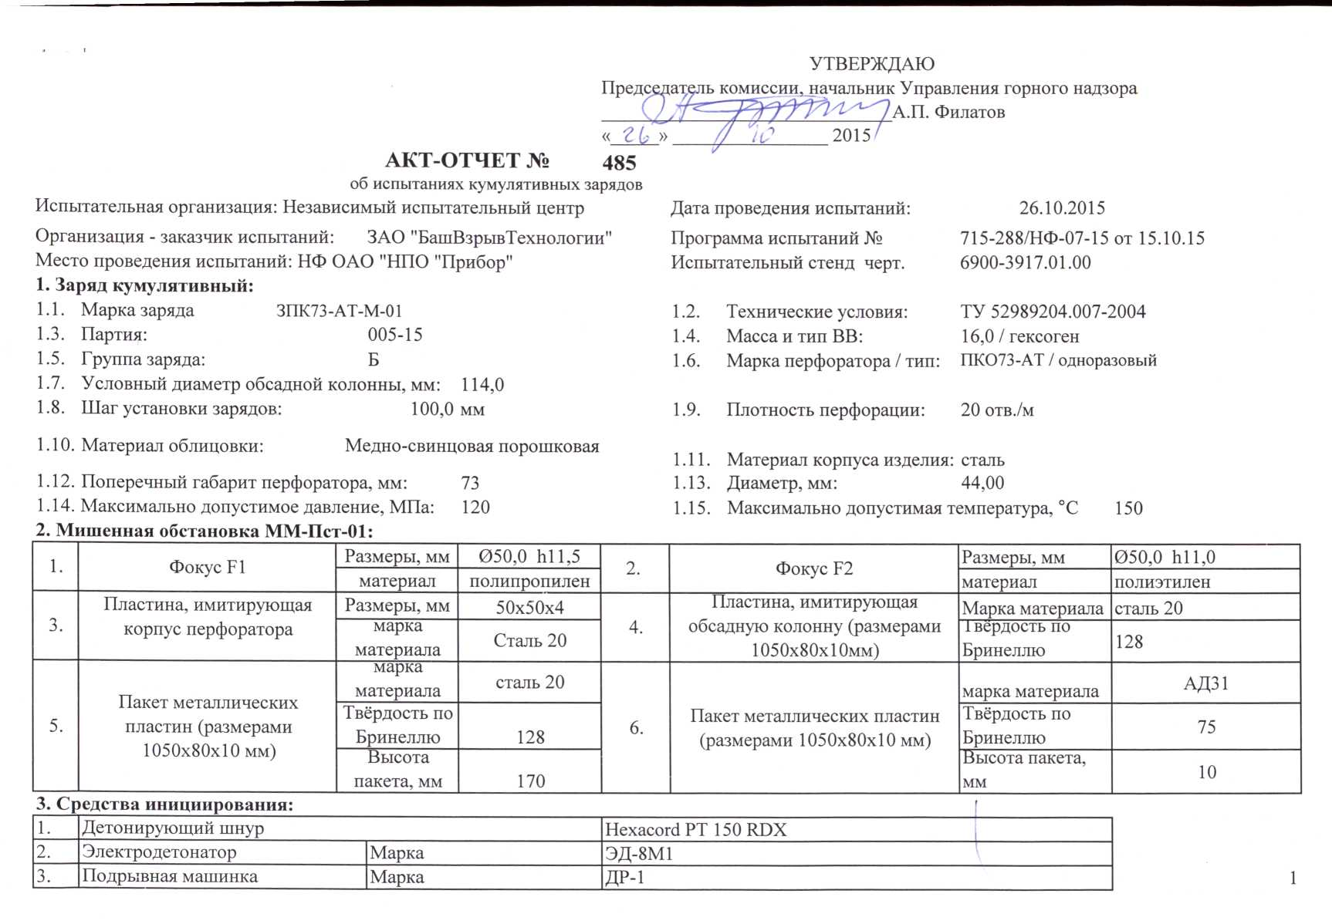
INCLUDEPICTURE "../../../../../../../TCA29~1.GAV/AppData/Local/Temp/FineReader12.00/media/image2.jpeg" \* MERGEFORMAT 